Oldham County
Fire Instructors Association

Standard Operation Procedures

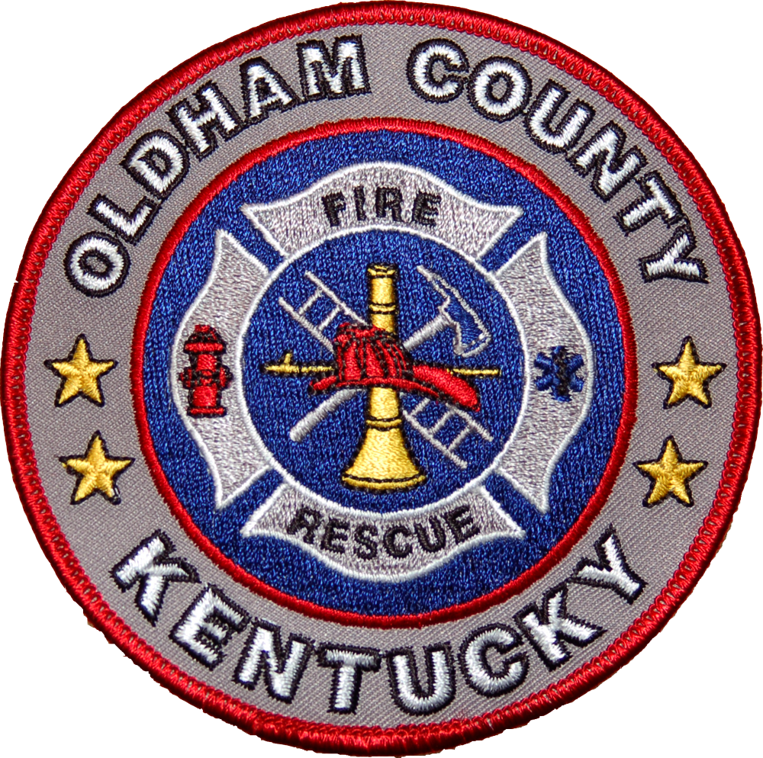

Last Revised August 2020

STANDARD OPERATING PROCEDURE
Chapter Table of Contents Page

Introduction 1
Chapter 1 Scope 1
Chapter 2 Purpose 1
Chapter 3 Definitions 1
Chapter 4 General Use of Facility 3
Chapter 5 Burn Building Fuels 4
Chapter 6 Internal and External Instructors 4
Chapter 7 Assigned Staff Instructor 4
Chapter 8 Fire Department Safety Officer 5
Chapter 9 Training Evolution Safety 6
Chapter 10 Drill Tower and Burn Building 7

INTRODUCTION
The Oldham County Regional Fire Training Center (OCRFTC) has been designed to afford training opportunities for various public safety disciplines.
To ensure the maximum effective use of this facility and the surrounding training grounds, this procedure has been developed. Identifying a process during operations as well as numerous safety procedures, these guidelines aim to provide the best possible training with the highest margin of safety.
It is the intent of the Oldham County Instructors Association to provide a safe and realistic training facility as well as one which will enhance the learning opportunity and skill development of those who use this facility.
Train safe ... train often.
Chapter 1 Scope
1-1 The SOPs apply to all personnel; including staff, instructors, students, visitors and others who may have an opportunity to use the OCTC and associated training grounds.
Chapter 2 Purpose
2-1 The purpose of this Standard Operating Procedure (SOP) is to minimize the risk to all participants, promote good housekeeping and ensure the maximum life of all props and buildings on the facility.
Chapter 3 Definitions
3-1 Participant – anyone actively involved in training evolutions including students, staff and instructors.
3-2 Evolution- A set of prescribed actions that result in an effective fireground activity.
3-3 Staff Instructor –The OCFIA certified County Fire Instructors specifically trained and assigned to provide supervisory and safety support to County agencies wishing to use the Live Burn Fire Training Facility.
3-4 “Assigned Instructor Briefing Checklist” – The “Assigned Instructor Briefing Checklist” will be used as the minimum standard of safety. At no time will live evolutions be initiated without the appropriate safety briefing, inspection of Personal Protective Equipment (PPE), tour of the facility, appropriate staging of apparatus ensuring minimum required water supply and placement of hoselines. In addition, the location of the Command Post and Safety Officer Position. We will utilitze the Kentucky Fire Commission Application for Live Fire Training.
3-5 RIT Team – A RIT Team shall be established and will consist of at least four (2), preferably four (4), RIT qualified firefighters. This team will be assigned to a designated staging area for the duration of the live fire operations, unless otherwise released. This will be in accordance with the Oldham County RIT policy.
3-6 Adequate Water Supply- When conducting “live fire” scenarios we will be compliant with the National Fire Protection Association guidelines as outlined in NFPA 1403, “Standard on Live Fire Training Evolutions” which states:
> The instructor-in-charge of the live fire training evolutions shall determine, prior to each specific
evolution, the number of training attack lines and backup lines that are necessary.
> Backup lines shall be provided to ensure protection for personnel on training attack lines.
> Each hose-line shall be capable of delivering a minimum of 360L/min (95 GPM).
> The instructor-in-charge shall assign the following personnel:
- One instructor to each functional crew, which shall not exceed 5 students
- One instructor to each backup line
- Additional personnel to backup lines to provide mobility
- One additional instructor for each additional functional assignment
NOTE: Separate sources shall be utilized for the supply of attack lines and backup lines in order to preclude the loss
of both water supply sources at the same time.
3-7 Ignition Officer- An individual, who is not a student, shall be designated as the “ignition officer” to control the materials being burned.
3-8 Pump Operator –An individual assigned to the operation of an engine during live burn operations. A pump operator must be assigned to each engine used for an evolution who is both authorized and qualified to operate the engine.
3-9 Safety Officer- An individual appointed by the requesting agency as qualified to maintain a safe working environment at all training evolutions.
3-10 Student. -Any person who is present at the live fire training evolution for the purpose of receiving training.
3-11 Training Grounds. For the purpose of this procedure, everything in the fence area of the OCTC.
3-12 Clean-up. The removal and proper disposal of all items brought to or used during training evolutions including debris left in burn rooms, car fire prop and any post fire debris on the facility.
3-12.1 Evolutions conducted by law enforcement and other agencies using firearms as part of the training, require the “policing” of brass upon the conclusion of the training due to the significant slip/trip safety hazard imposed by the spent rounds for others using or working in the area.
3-13 Operations Area. Area defined as all areas where live fire and support operations are being conducted.
Chapter 4 General Use of Facility
4-1 The Oldham County Fire Instructors Association requires that each user be briefed of contents of this SOP before using the facility. Copies of the SOPs will be sent to each fire department.
4-2 A pre-burn plan shall be prepared and utilized during the pre-burn briefing. All features of the training area and structure(s) shall be indicated on the pre-burn plan. A copy will be submitted with fire department’s request for use of the OCRFTC.
4-3 The Fire Department Officer-in-charge or designee requesting the use of the facility will ensure that all students participating in a live burn have a signed Live Fire Course Competency Validation/ Fitness for Duty Form.
4-4 Participants shall be in full Occupational Safety and Health Administration (OSHA) compliant protective clothing.
4-4.1 Students with beards or any facial hair that may interfere with a proper face mask seal, shall not be allowed to wear SCBA or be permitted to participate in evolutions which may expose them to smoke or toxic environments. Participants must have been fit tested by their home department prior to participation.
4-5 Spectators will be restricted to an area outside of the operations area. Personal protective equipment is not required in this area.
4-6 Problems concerning operational issues with the facility will result in termination of all activities. Activities are not to resume until the situation can be corrected.
4-7 The Fire Department requesting use of the facility must make arrangements for emergency medical support.
4-7.1 Emergency Medical support will include a minimum of two (2) EMT – basic and basic medical equipment.
4-7.2 Minimum medical requirements do not require a transporting ambulance be on site. As good practice OCEMS will be notified and will provide an ambulance on standby if requested however this is not guaranteed.
4-8 Weather forecast. Because of the construction of the live burn facility, as well as the openness of the site, care must be exercised when conducting evolutions when electrical storms with lighting strike potential may pose a safety issue. Awareness of weather conditions, wind velocity and wind direction shall be maintained, including a final check for changes in weather conditions immediately before actual ignition.

Chapter 5 Burn Building Fuels
5-1 The quantity of fuel used shall be limited to the amount necessary to meet the objective. The assigned Staff Instructor(s) will review and approve the fuel load.
5-2 Class A fuels are the only fuels permitted in the burn building (OCRFTC).
5-2.1 Example would be pallet-like material, excelsior, paper, cardboard, straw, hay and other ordinary combustibles.
5-3 Prohibited materials include pressure treated wood, rubber, tires and plastic materials, straw or hay treated with pesticides or harmful chemicals are prohibited in the burn building.
5-3.1 Fuels that may be contaminated by toxic or unknown materials shall not be used.
5-3.2 Class B fuels, flammable or combustible liquids, shall be prohibited in the burn building.
Chapter 6 Internal and External Instructors
6-1 No agency will be permitted to use the live burn facility without an assigned OCFIA Instructor on site.
6-1.1 The Oldham County Fire Instructors Association will arrange for an assigned Instructor to be present each time the facility is used.
6-2 One Outside Safety Officer and one Interior Safety Officer shall be the minimum assigned for all live burns in the burn building.
6-3 The Fire Department Safety Officers shall not be assigned other duties that will interfere with his or her primary responsibility of safety.
6-4 The requesting Fire Department must supply a minimum of one (1) Safety Officer and one (1) Training Officer. The Fire Department Chief Officer and Training Officer will be in charge of the Training Lesson Plan and its content, pending approval by the assigned Staff Instructor.
6-5 The Fire Department Line Officer or Training Officer to student ratio shall be 1 to 5 for both interior and exterior operations.
Chapter 7 Assigned Staff Instructor
7-1 The assigned Staff Instructor(s) shall be in full Occupational Safety and Health Administration (OSHA) compliant personal protective equipment (PPE) during training evolutions.
7-2 Safety shall be the primary responsibility of assigned Staff Instructor(s) at all times.
7-3 The assigned Staff Instructor(s) shall identify a recognized departmental accountability system.
7-4 The assigned Staff Instructor(s) shall have the authority and responsibility of keeping the training grounds risk-free. The assigned instructor(s) shall review the burn plan prior to briefing the students.
7-5 The facility shall be visually inspected for damage by the Staff Instructor(s) along with the Fire Department Safety Officer prior to each use and upon completion of the training. Any damage or deficiencies noted will be reported in writing to the Oldham County Fire Instructors Association. Training shall not be permitted in the event burn building damage is severe enough to affect the safety of the participants.
7-6 It is the responsibility of the assigned Staff Instructor(s) to postpone or terminate all activities in the event that any operational issues or problems have been identified with the facility; completing a written report to the Oldham County Instructors Association.
7-7 The assigned Staff Instructor(s) will ensure that the facility is secured and all Association-owned equipment is cleaned and stowed away. All trash, garbage and spent material will be picked up and disposed of by the agency using the Live Burn Training Facility or Training Grounds after all training evolutions are complete.
7-8 The assigned Staff Instructor or one of the assigned instructor(s) is responsible for ensuring proper radio communication is in place to readily contact fire dispatch, ambulance or other help, if needed.
Chapter 8 Fire Department Safety Officer
8-1 A minimum of one (1) Fire Department Safety Officer is required for all evolutions.
8-2 The Fire Department Safety Officer(s) shall be visibly identified by means of a vest furnished by his/her department.
8-3 The Safety Officer shall have the authority, regardless of rank, to intervene and control any aspect of the operations when, in his/her judgment, a potential or actual danger, accident or unsafe condition exists.
8-4 The responsibilities of the Safety Officer shall include, but are not limited to, the following:
- Prevention of unsafe acts
- Elimination of unsafe conditions
8-4.1 The Safety Officer shall provide for the safety of all persons using the OCRFTC including students, instructors, visitors and spectators.
8-4.2 Supervises additional Fire Department Safety Officers as needed. Additional safety personnel as
deemed necessary by the Safety Officer may be placed strategically within the OCTC to react to any unplanned or threatening situation or condition
8-4.3 The Safety Officer ensures that all personal protective equipment (PPE), including self-contained breathing apparatus (SCBA). Personal Alert Safety System (PASS), protective hoods and gloves are required. All must be in serviceable condition and in compliance with current OSHA Standard.

8-4.4 The facility shall be visually inspected for damage by the Staff Instructor(s) along with the Fire Department Safety Officer prior to and after each use. Any damage or deficiencies noted will be reported in writing to the Training Technician. Training shall not be permitted in the event burn building damage is severe enough to affect the safety of the participants.
8-4.5 The Safety Officer monitors accountability both pre- and post-burn.
8-4.6 The Safety Officer ensures that the apparatus operator (AO) maintains his or her position at each pumper during live burns. The apparatus operator may not be an assigned instructor or a student in the evolution.
Chapter 9 Training Evolution Safety
9-1. Visually inspecting the facility for damage prior to and after each use.
9-1.1 The facility shall be kept in a safe condition between evolutions and in a safe and clean condition before the user leaves the property. Debris hindering the access or egress of firefighters shall be removed before continuing.
9-2 Prior to live burns, a pre-burn briefing session shall be conducted for all personnel involved in the evolution. Prior to conducting live burns all participants shall be required to have an orientation of the burn building, The location of simulated victims is not required to be disclosed, provided that the possibility of victims is discussed during the pre-burn briefing. At no time shall a live person be used for a victim.

9-3 The burn building evacuation plan shall be verbally communicated and demonstrated to all involved participants. The evacuation plan is a continuous activation of an air horn. This sounding represents an emergency or perceived emergency and requires that all people exit the drill tower and burn building.
9-4 Primary and secondary hose lines shall be a minimum of 1^{3/4}-inch diameter. A minimum of one secondary hose line shall be provided to ensure adequate protection for the students in the burn building. The water supply for secondary hose lines must have an independent water source. RIT shall have a dedicated hose line a of minimum of 1^{3/4}-inch diameter.
9-5 Artificial smoke - Training evolutions are conducted using artificial smoke generated by a “Smoke Fogger” in order to provide limited visibility without the use of live fire and heat. Evolutions using “artificial smoke” do not require the water supply requirement nor any of the other “live fire’ requirements.
9-6 The decision to ignite the training fire shall be made by the Fire Department Officer in Charge in conjunction with the assigned Staff Instructor(s) and the Safety Officer.
9-7 A charged hose line shall accompany the Ignition Officer when he/she is igniting any fire. The only exception will be pan fires for extinguisher training. Safety for this evolution will include at least one fully charged, dry chemical extinguisher, manned while pouring fuel in the pan and during ignition.

9-8 Live Fire within the Training Center Burn Building shall be confined to the designed “burn areas”.
9-8.1 NOTE: It is NOT permissible to conduct simultaneous fires. No more than one live burn will be permitted in the burn building at one time.
9-9 No person(s) will be placed inside the burn building to play the role of a victim. Under NO circumstance will the use of live “victims” during live burn evolutions be allowed.
9-10 After the last live burn is completed, prior to cleaning up of the burn building; the assigned Staff Instructor(s) will sample the air quality to determine if the building is safe to enter without self-contained breathing apparatus (SCBA).
9-11 The assigned Staff Instructor(s) will discontinue operations if the internal burn room temperature is deemed to be excessive. Ventilation to cool the burn rooms will be initiated.
9-12 Provisions will be made for the rest and rehabilitation of participants. A designated rehab area will be established under the direction of the Safety Officer with an adequate supply of drinking water available for participants.
All injuries and illnesses must be reported to the assigned Staff Instructor at the earliest opportunity.
Chapter 10 Burn Building
10-1 A staging area will be designated to stage personal vehicles, fire trucks and ambulances, which are not part of the evolution, so as to not interfere with fire ground operations.
10-2 Restrooms are located in the main building adjacent.
10-4 The burn building evacuation plan shall be verbally communicated and demonstrated to all involved parties
10-5 The plan calls for a continuous sounding of an air horn style device. This sounding represents an emergency or perceived emergency and requires that all people exit the drill tower and burn building.
10-6 All openings, including door and windows shall be inspected and operated; doors will remain unlocked, prior to any live burns in the burn building.
10-7 All post-burn material shall be extinguished. As part of the final safety inspection, all live fire debris shall be removed from the burn room and deposited in the appropriate refuse site.

